A Language-Independent Approach for Tracking Source Code Lines

Daniel Lien
Computer Science
Windsor, Ontario, Canada
liend@uwindsor.ca
110135508
Wilson Tran
Computer Science
Windsor, Ontario, Canada
tran9b@uwindsor.ca
110133989
Liana Bell
Computer Science
Windsor, Ontario, Canada
bell23@uwindsor.ca
110137349
Tyler Wang
Computer Science
Windsor, Ontario, Canada
wang5m2@uwindsor.ca
110146913
Nazifa Tahsin
Computer Science
Windsor, Ontario, Canada
tahsin4@uwindsor.ca
110125082

The goal of this project is to create a language independent program that matches and tracks lines for 2 files. We used an Agile and Iterative development process, with an object orientated approach in Java and divided each step of our program into iterative developments. We were able to create a relatively accurate line tracking system that can handle most basic cases, including identical line matches, similar line matches, and even line splitting, but fails on some edge cases.
Keywords—Java, Agile Development, Line Comparator, Levenshtein

Introduction
Given two different versions of a file, how do we track lines between them? This was the problem we had to solve. During our first group meeting, we discussed and decided how we intended to approach the problem. After some discussion and a few debates, we ended up doing an object-orientated and iterative development method in Java. Our plan was to divide our program into multiple classes and objects, and each of us would work on different components of the overall system. Throughout the development process, our LineComparator class (the class that handles line matching) would be modified and updated, allowing our tester to run tests on the code to find bugs and edge cases. Then using the feedback from the tests, the code is further refined and improved to iteratively build our final product. In the end, after several iterations, our LineComparator class can handle most line matching cases, from identical, similarity and line splitting matches. For small test samples, the code would have an accuracy upwards of 90%, but on larger tests, goes down to roughly 60-70%. It is still mostly accurate, but through our tests, we found many edge cases that kept getting more and more complicated to solve, which is why the accuracy is lower for bigger and more realistic test samples.

Designing
Before any code could even be written, we needed to figure out how to structure everything and the specifics of how things would be implemented. As all the classes in our program would be written by a different person, we all needed a general design to follow, or else our code wouldn’t work together. Thus, a first draft diagram detailing each class, their functions, inputs and outputs, was created. We decided on a basic structure with several classes that implement different parts of the program with the Main class connecting them all. The diagram was updated several times through the iterative process as we came up with better solutions and updates.

An Example Of The Design Diagram
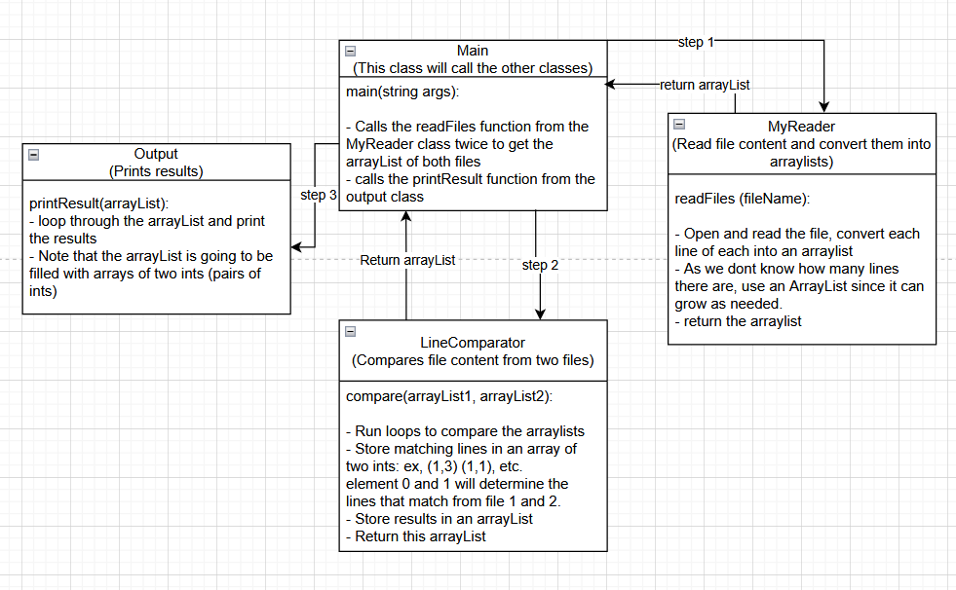

Implementation
With a general structure created, we were able to quickly make our first working prototype. For this first prototype though, we only focused on making it work. As such, we only implemented identical matching in the LineComparator class, meaning only lines that have the exact same content could be matched. This was part of the iterative development process, as we divided each level of implementation into separate development periods. We started off with just identical line matches, and once we confirmed that it worked with no bugs, we moved onto implementing the next level: similarity matching. Then once again, we check for bugs and issues, before we move onto the final section, line splitting. We continued this implementation and testing cycle until we ended up with what we have. Below, will be a more in depth explanation of how each iteration of LineComparator was implemented.

Identical Matching
Identical line matching is the first, and the simplest to implement. Simply loop through the lines of both file 1 and file 2, that are stored as strings in an arraylist, and check if the line contents are identical. If they are identical, we add the line number pair to an array of matched lines. This array of matched lines is what stores the result of all matches in all the steps.

Similarity Matching
Similarity matching is more difficult to implement than identical matching. We now have to consider lines that are similar, but not identical. For example, changing the name of a variable but its value and purpose remain the same.
To solve this, we need to calculate the difference between the two lines. For this, we used the Levenshtein Distance method included in the ApacheCommonText library. By calculating the levenshtein distance, we determine how many changes it takes to get from the first line to the second, or in other words, how “different” the two lines are. Using this levenshtein value, we can filter out lines that have too big of a difference and match lines with a small difference. However, we discovered a problem with this, which was that shorter lines tend to have smaller levenshtein distance scores, despite being more different than longer lines. For example, the strings “ab” and “cd” have a levenshtein score of 2, while “example123” and “example456” is 3. The first example of “ab” and “cd” are clearly more different as they share no characters, yet its score is smaller than the second. To solve this, we normalized the score. By dividing the levenshtein distance with the combined length of the strings, we get a value from 0 - 1, which accurately tells us how different two lines are regardless of length.
Now that we have the normalized levenshtein distance, we know how different the content of the two lines are, which is the content score. But that isn’t enough to determine if two lines should be matched. There are cases where two lines look similar but shouldn’t be matched. For example, “int variable1 = 1” and “int variable2 = 5.0”. For cases like these, we must also calculate the context score, which is how different the surrounding lines are. To get this context score, we calculate the average of the normalized levenshtein distance of the previous and next lines of both lines we are comparing. Normalized Levenshtein Distance of previous line 1 and 2, plus, normalized levenshtein distance of next line 1 and 2, and then divide by two to get the average. If there is no previous or next line, we set it to an empty string. With both the content and context score, we can now figure out the overall difference score of the two lines. We use the formula (0.6*contentScore + 0.4*contextScore), which was recommended in the project instruction.
We keep track of the lowest difference score within a nested for loop that loops through all the lines of the first and second file. This way we know what the best and most similar match is. Then if the difference score of the best match is less than a certain max difference value, we match them. Otherwise, we don’t match it. Note that this max difference value is adjustable.

Line Splitting
Like with similarity matching, line splitting uses the normalized levenshtein distance function to measure how different lines are. The logic behind line splitting is that if the normalized levenshtein distance score goes down when you concatenate the next line, then it’s part of the line split. For example, if the first line is “This is a test line.” and the other lines are “This”, “is a”, “test line”. The normalized levenshtein distance between “This is a test line” and “This” is going to be quite large, but as you keep concatenating the other lines, it’ll gradually become more and more similar to the first line. “This is a test line” and “This is a” will have a smaller difference than if it was just “This.” We apply this logic in a loop, and keep concatenating as long as the next line reduces the overall difference. Once it starts increasing the difference, then it’s no longer part of the line split. Then we check if the difference score of the first line and the concatenated lines is below the max difference value (the same one from similarity diff), and if it is, we match the first line with all the line numbers of the concatenated lines.
To take it a step further, we also compared the context of the line split. The logic is the same as similarity matching, where we take the previous and next lines and get their average scores. We also use the same formula for difference which is (0.6*contentScore + 0.4*contextScore). However, as we concatenate another line, we update the “next line” of the second file, and recalculate the difference. This way we also make sure the line split matches are within similar contexts for further accuracy. Just like with identical and similarity matching, we apply all the above inside a nested for loop, comparing all the lines from the first and second file.

The Overall Line Matching Process
Our line comparator class contains all the methods explained above in separate functions. It runs all of them in sequential order, from identical matching, then similarity matching, and finally line splitting. Also, as the matching functions run, our code stores and updates an array of lines that have already been matched. The algorithm will check that array and automatically skip lines that have already been matched, so there won’t be dupes. Any unmatched lines at the end from the first file will be considered deleted while any unmatched lines from the second file is an added line.
Here is a GUI visualization of the process below. The orange yellow line shows the exact matches, which gets checked first. Then from the remaining lines, we see the similarity matches in blue lines. Finally, we have a line split shown with purple pink lines. The remaining lines are unmatched, with red highlights representing deleted lines and green highlights showing added lines.
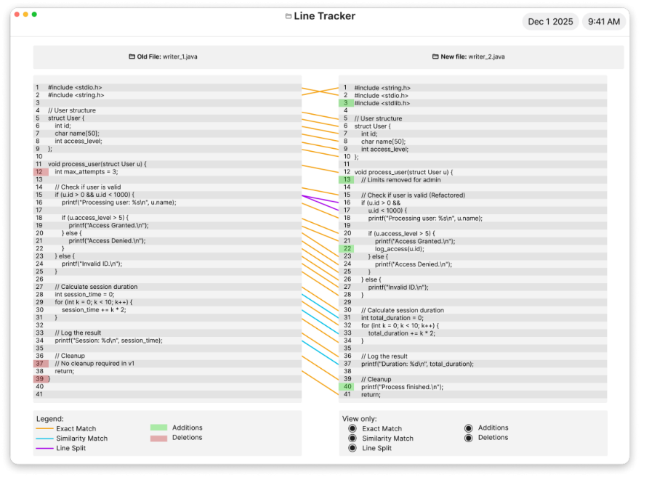

Data collection
To test our code, and ensure accuracy, each member of our team contributed 5 pairs of test cases each (25 pairs of files and over 500 mappings in total), and almost every test case was handpicked from actual code we wrote in the past (with the exception of some written text files used for verification and edge case testing), such that each test case would be realistic input for the software. After, we manually went through and wrote the XML mappings for each test case. These test cases and files were then used for our testing and iterative development process to find bugs and improvements to our code.

Testing and verification
Our testing and verification strategy began with a single dataset, which allowed us to focus on ensuring the tool matched corresponding lines correctly. We used one class, called TestingCases.java to handle all the testing, and we’d call it in the main class. Multiple functions were created to help the process of testing the datasets that we had gathered. We had a debugger helper tool, which just outputted all of the line number contents, which made it easier to find bugs. Most of the code for the testing class were for calculating the amount of correct matches our tool would output vs the correct XML mappings. This function, dubbed as the “PercentageTest()” would return a percentage value of type double, which would give us a rough estimate of how our tool performed against the XML mappings. We then later used this method when we started automating our tests. Programming the automation made it easier to detect bugs, or find out what went wrong with our tool, as we could check which test cases it would fail in the most. We then output all the results to a CSV file, to make it easier to distinguish between all of our test cases. Out of 500 XML mappings in our datasets, we got around 465 (93%) mappings correctly identified by our tool. Below is the data we collected from all the datasets we used.
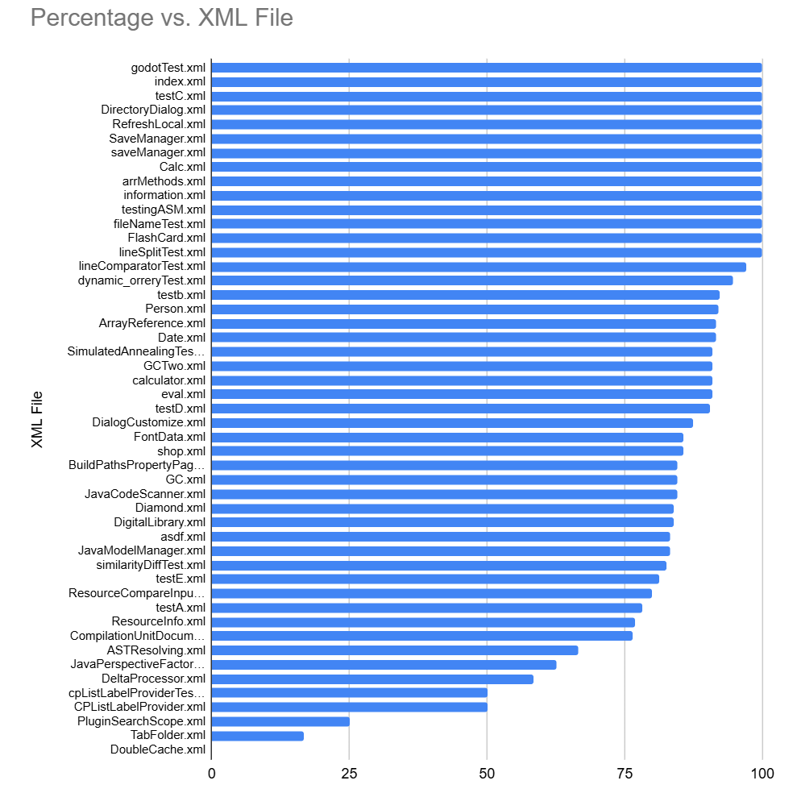
As you can see from the results, with the exception of a few testcases, most of the testcases performed really well. E.G “Double Cache”, which performed extremely badly, since our tool only checks for line splitting in one direction (line split tries to match a single line from file 1 to multiple lines in line 2). Double cache had line combining, where multiple lines in file 1 were combined into one line in file 2. However, a simple solution is to simply reverse the order of the input files which improves accuracy. “Plugin base” had a lot of variety in the test, such as method renames, deletions and even more changes. For such cases, minor errors will add up causing more and more invalid matches. “Tab folder” had a lot of movement across files. The result ended up extremely poor because our code checks for matches in order of line number, so when it gets rearranged drastically, including line addition/ deletion, there is a lot of potential for mismatch. Fixing this would likely require a new algorithm or method to track a lot of big movement of lines, which is beyond what our current code and capabilities can do.

Our “MaxDiff” variable mentioned in the Implementation section is what determines what level of difference is accepted to be matched. It also determines how accurate the overall accuracy of our tool will be. As one can see from the graph below, as we set our MaxDiff closer to ~0.325, the accuracy peaks at around 83%.
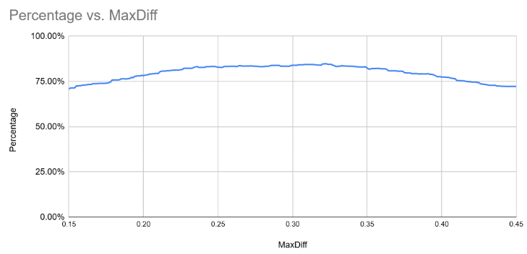

Identifying Bug-Introducing Changes (Bonus)
First the program looks at the newest commit message of the target file. It searches for keywords such as “fix”, or “bug”. If these keywords are detected, the program compares the file’s current version (HEAD) and the previous version (HEAD~1), using LineComparator. Lines that were modified or deleted are noted as “buggy lines”. The program goes through a loop, iterating backwards through previous versions. It compares the buggy lines in the version that is currently being analyzed, with the version prior to it. Buggy lines that are matched with the older version are “inherited” and we must keep looping back in version history to find where those lines are introduced. Buggy lines that do not have a match in its older version, are considered introduced in the current version. When reaching the oldest version, i.e. the first version, all buggy lines we are still tracking are considered introduced in that version.

To evaluate this approach, I created a local Git Repository and created files with different commit history situations to test that the program runs as desired. The first file that I evaluated introduces a bug in version 2, and the final version fixes the bug. It ran as expected, identifying when the bug was introduced. The second file had a bug introduced in version 2, then a series of unrelated commits, and finally a bug fix. It ran as expected, identifying versions when the buggy line was inherited and continuing backwards to find the bug’s origin. The third file I evaluated had different bugs introduced in different commits that were fixed simultaneously in the final version. It ran as expected, and the program was able to search backwards for different bugs with different origins and print the results.

Acknowledgment and references
The Common Lang Text library was used in our project for the levenshtein method.

